Task 1: To Create Main Loop, Display Prompt, Read User Input, Handle Exit Conditions, Design Control Flow Diagram, Test Interactive Loop
Code:
#include <stdio.h>
#include <string.h>
#define MAX 256
int main() {
char input[MAX];
while (1) {
printf("mysh> ");
fflush(stdout);
if (fgets(input, sizeof(input), stdin) == NULL) {
printf("\n");
break;
}
input[strcspn(input, "\n")] = '\0';

if (strlen(input) == 0)
continue;

if (strcmp(input, "exit") == 0) {
printf("Exiting shell...\n");
break;
}

printf("You entered: %s\n", input);
}
return 0;
}
Output:
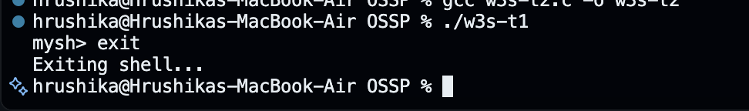

Task 2: Using the following system calls, copy the content from File1.txt to File2.txt.
- Open()
- Read()
- Write()
- Close()
open()
syntax: open(“ filename.txt”, modes, permissons)
Example: open(“First_Prgm.txt”, O_CREAT | O_WRONLY, 0644);

Table 1: Modes of Open system call
Flag | Purpose
O_RDONLY | Open for read only
O_WRONLY | Open for write only
O_RDWR | Open for both read and write
O_CREAT | Create file if it does not exist
O_TRUNC | Truncate (empty) an existing file
O_APPEND | Append data to the end of the file
O_EXCL | Fail if file already exists (used with O_CREAT)

read()
Syntax: read(int fd, void *buf, size_t count);
Example: read(fd, buffer, 100)
#include <stdio.h>
#include <unistd.h>
int main()
{
char buffer[100];
int n;
printf("Enter some text: ");
n = read(0, buffer, sizeof(buffer) - 1);
buffer[n] = '\0'; // Null-terminate the string
printf("You entered: %s", buffer);
return 0;
}

write()
Syntax: write(int fd, const void *buf, size_t count);
Example: write(fd, message, 11);
#include <unistd.h>
int main()
{
write(1, "Hello World\n", 12);
return 0;
}
Code:
#include <stdio.h>
#include <stdlib.h>
#include <unistd.h>
#include <fcntl.h>

#define BUF_SIZE 128

int main() {
int fd1, fd2, n;
char buffer[BUF_SIZE];

fd1 = open("File1.txt", O_RDONLY);
if (fd1 < 0) { perror("open File1.txt"); exit(1); }

fd2 = open("File2.txt", O_CREAT | O_WRONLY | O_TRUNC, 0644);
if (fd2 < 0) { perror("open File2.txt"); close(fd1); exit(1); }

while ((n = read(fd1, buffer, BUF_SIZE)) > 0) {
if (write(fd2, buffer, n) != n) {
perror("write");
close(fd1); close(fd2);
exit(1);
}
}
if (n < 0) perror("read");

close(fd1);
close(fd2);
printf("File1.txt copied to File2.txt successfully.\n");
return 0;
}

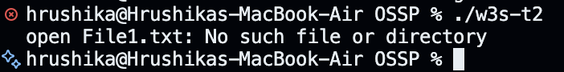
Output:

